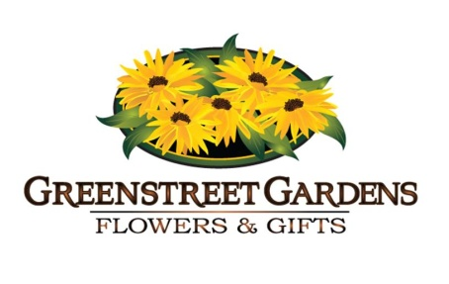
Birthday Celebrations at
Greenstreet Gardens!
Having your child’s birthday at Greenstreet Gardens is a wonderful idea! There are so many fun activities for your child and your guests to participate in here on our farm. Many memories will be made on your visit to Greenstreet!
Your party package will include a personal hostess and access to all the fun activities we have to offer here during Fall Festival. This includes hair and face painting, cow train ride, hayride, corn box, underground slide, jumping pillow, tire maze, straw climbing castle, shortie maze and of course our 5 acre corn maze!

2013 Birthday Party Package $165
15 guests included in the party package
Reserved Picnic tables for 2 hours
Party Hostess
Admission Wristbands for each Party Guest (ages 0-100)
Birthday child is FREE
- Complimentary Party Wristbands for Birthday Child’s Parents

Souvenir T-Shirt for Birthday Child

“Shorties” are no charge; 30” and under
Additional Options
$10 per person for each additional guest.
$10 per pizza, which we will arrange and deliver right to your table.
To make your October weekend birthday party, please email us at birthdays@greenstreetgrowers.com or by calling Amanda at 443-624-6909.
Once your party is booked and confirmed with a $50 deposit, we will send you a confirmation packet with helpful reminders and other important details to help you have the best day possible here on the farm!

